Study Smart Bug 1.9  
  
1.Register Scenario   
  
  
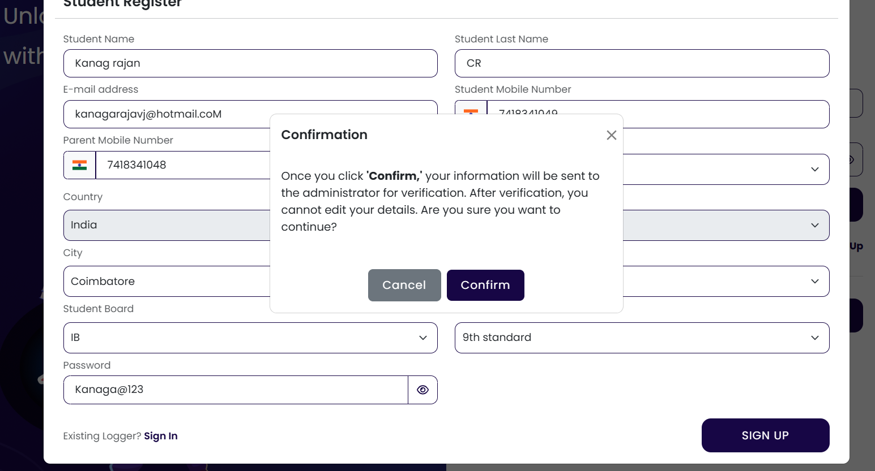  
  
When a user types an email like @gmail.coM, the app should automatically convert uppercase letters to lowercase (e.g., @gmail.com). This ensures consistency, avoids validation issues, and improves user experience by displaying emails in a standardized format as they type.

|  |  |  |  |  |
| --- | --- | --- | --- | --- |
| Module | Sub Module | Bug Created By | Bug Resolved By | Remarks |
| Register | Rewards | Vigneshwar CR |  |  |
|  |  |  |  |  |

2. Mail content   
  
In mail content On Board should be like this not like Onboard .

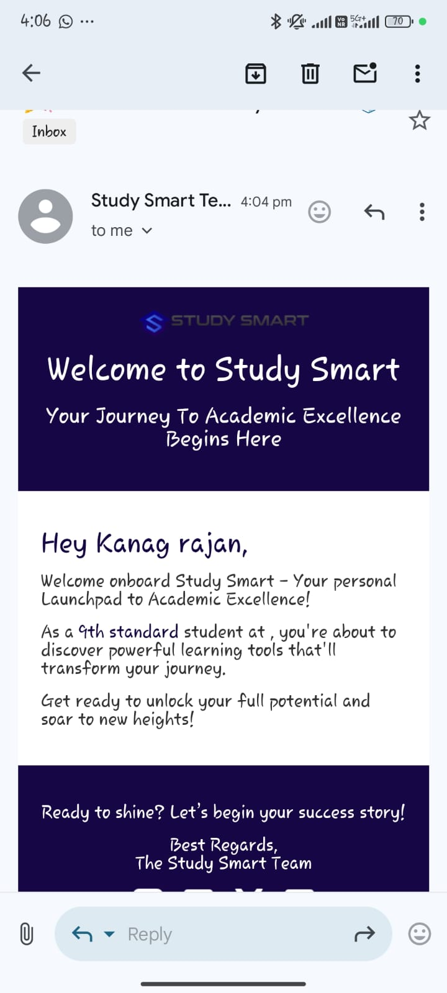

|  |  |  |  |  |
| --- | --- | --- | --- | --- |
| Module | Sub Module | Bug Created By | Bug Resolved By | Remarks |
| Register | Rewards | Vigneshwar CR |  |  |
|  |  |  |  |  |

3. Register   
  
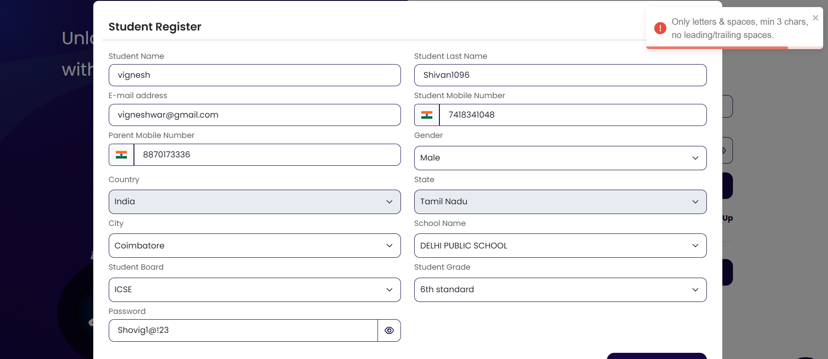  
  
The popup should appear in the correct field and be highlighted using color codes for better visibility.  
  
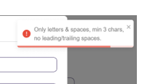

4. Register   
  
  
  
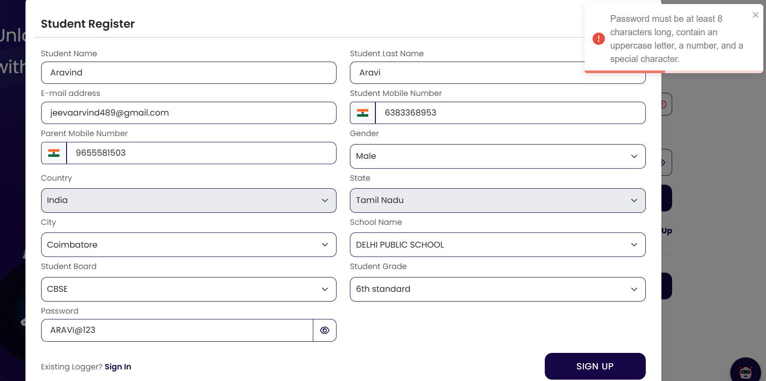  
  
while using full Upper case letter in password error is pushing at the top of the app, But it should mention with content like ( 8 charter in length , contains upper case, lower case, anumber and